MENU
JERK CHICKEN
JERK CHICKEN BUN JERK CHICKEN STRIPS
Jerk-marinated chicken breast with our signature Fried chicken strips topped with
sweet & spicy jerk sauce on a brioche bun sweet & spicy jerk sauce
£8 £7.50
THE JERK MEAL
Sliced jerk-marinated chicken breast covered in our signature sweet & spicy jerk sauce with sweet potato fries
£10

JERK BBQ CHICKEN STRIPS
Our signature buttermilk-soaked, tempura battered jumbo fried chicken strips. All our chicken is free range and halal.
Two Chicken strips £4.75 Four Chicken strips £7.75
Three Chicken strips £6.25 Four halloumi strips £6.50

SAUCES
BBQ Franks hot sauce American Ranch Lime mayo
Chilli mayo Ketchup Jerk Sweet chilli
(extra sauce £1)

FRIED CHICKEN
CHICKEN STRIPS CHICKEN BURGER
with honey mustard mayo fried chicken breast burger topped with cheddar & mayo on a brioche bun
£6.50 £8

BBQ CHICKEN STRIPS STRIPS’N CHIPS
topped with BBQ sauce Fried chicken strips served with fries
£7 £9 / with cheese fries £10

Nachos:
tortilla chips loaded with nacho cheese, cheddar, tomato salsa, sour cream, guacamole and jalapeños £8
BBQ burger nachos: tortilla chips with BBQ beef burger topping, nacho cheese, cheddar, tomato salsa, sour cream, guacamole and jalapeños £10
House steak burger: loaded with cheddar, smoked streaky bacon & mayo £12
Chilli burger: beef steak burger with jalapeños, cheddar & chilli mayo £12

BAR SNACKS
Fries (V) £3
Cheese fries (V) £4.50

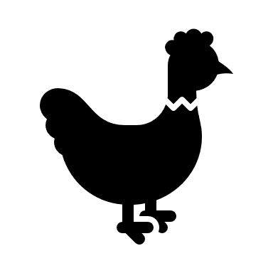ALL OUR CHICKEN IS HALAL
V=VEGETARIAN / VE=VEGAN
PLEASE INFORM US OF ANY ALLERGIES

Cajun skin-on chips with chilli mayo (V) £3.50
Sweet potato fries with American ranch sauce (VE) £3.50
Mac’n’cheese bites with BBQ sauce (V) £5
Houmous with pittas/ Spicy houmous with pittas (VE) £4.50
Halloumi fries with za’atar spice & mint yoghurt dip £5.50 (V) £5.50
‘The works’ potato skins: loaded with chilli beef, cheddar, bacon & sour cream £6.50

